**Understanding GitHub Use Cases**

GitHub offers a variety of functionalities depending on your needs. Here's a breakdown of some common use cases:

**1. Understanding GitHub Account Types:**

There are two main account types on GitHub:

* **Free Account:** This is the most common type, offering basic features like creating public repositories (visible to everyone), collaborating on public repositories, and using some limited automation features.
* **Paid Account (Individual or Organization):** Paid accounts offer additional benefits, such as creating private repositories (only accessible to authorized users), increased storage space, more advanced collaboration features, and access to additional tools and features.

**2. Changing Repository Type (Public to Private):**

* **Making Your Code Private:** If you're working on a personal project or something confidential, you can choose to make your repository private. This restricts access to only those you invite as collaborators.
* **Switching Types:** To change your repository type from public to private, navigate to your repository's settings on GitHub. There should be an option to change the visibility settings.

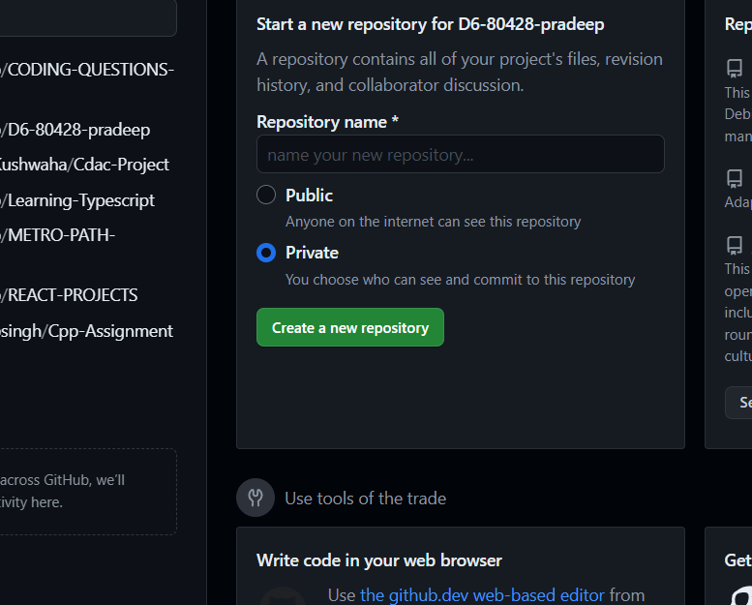



**3. Pushing Commits to a Public Repository:**

* **Sharing Your Work:** Once you've connected your local project to a remote repository (public or private), you can use git push commands to send your local code changes (commits) to the remote repository on GitHub.
* **Public Repositories and Visibility:** Remember, anything pushed to a public repository is visible to everyone on the internet. Make sure you're comfortable sharing the code before pushing.

**4. GitHub Account Security:**

* **Keeping Your Account Safe:** GitHub takes security seriously. They offer features like two-factor authentication (2FA) and personal access tokens (PATs) to enhance account security.
* **Understanding Security Measures:** It's crucial to enable 2FA and use strong passwords to protect your account. Use PATs cautiously, granting only the necessary permissions to specific tools or applications.

**5. Adding Collaborators (Private Repositories):**

* **Working Together on Private Projects:** Private repositories allow you to collaborate with others on your code. You can invite specific users as collaborators, granting them access to the codebase.
* **The Invitation Process:** To add a collaborator, navigate to your repository's settings on GitHub. Look for the "Collaborators" section and invite users by entering their usernames.

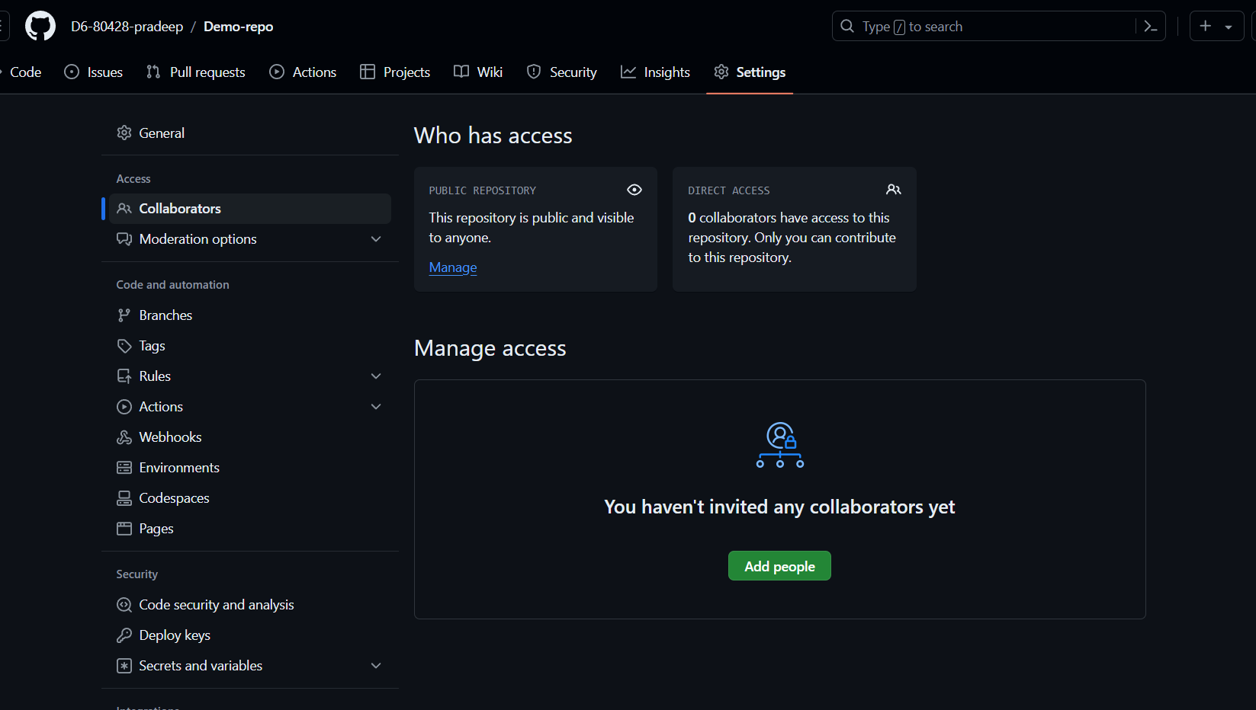



**6. Collaboration in Private Repositories:**

* **Teamwork Makes the Dream Work:** With collaborators, you can work on the same codebase simultaneously. Utilize features like branches and pull requests to manage changes effectively.
* **Communication is Key:** Communicate clearly with your collaborators to avoid conflicts and ensure everyone's on the same page.

**7. Owner vs. Collaborator Rights:**

* **Owner's Control:** The owner of a repository has full control over its settings, collaborators, and code. They can add/remove collaborators, edit files, manage branches, and delete the repository.
* **Collaborator Permissions:** Collaborators can have varying levels of access depending on what the owner grants them. Typical permissions include read (viewing code), write (editing code), and admin (managing branches, collaborators, etc.).

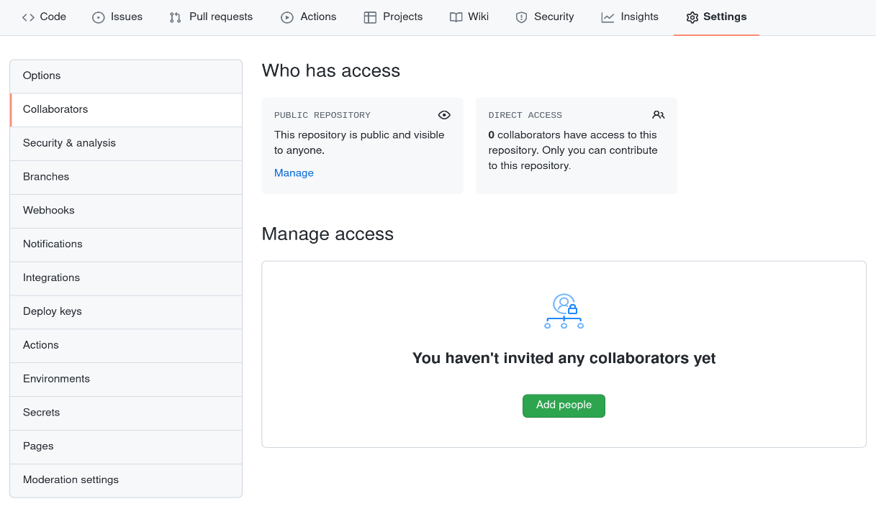

**8. Limiting Interactions (Blocking Users):**

* **Maintaining a Safe Environment:** If someone is harassing you or disrupting your work on GitHub, you can block them. This prevents them from following you, commenting on your repositories, or sending you messages.
* **Blocking Process:** You can typically block users from their profile page on GitHub.

**9. Introducing Organizations:**

* **Teams Made Easy:** Organizations allow multiple users to collaborate on projects under a single umbrella. This is useful for companies, open-source projects, or any group working on multiple repositories.
* **Creating an Organization:** To create an organization, you'll need a paid GitHub account. You can then invite other users to join your organization and grant them appropriate permissions.

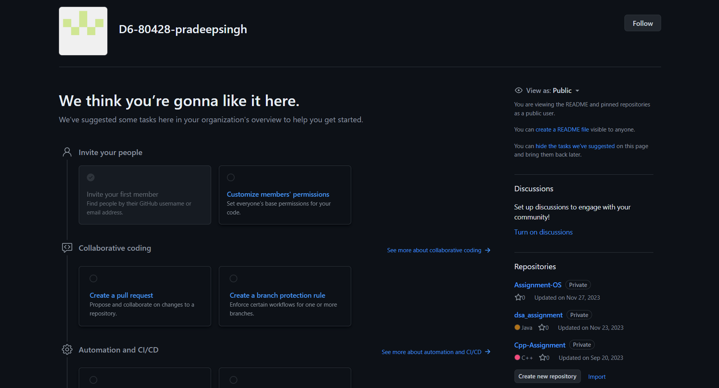

Organization



repositories



**10. Member Repository Permissions:**

* **Controlling Access Within Organizations:** An organization owner can define different permission levels for members, such as allowing them to view and clone all repositories, contribute to specific repositories, or have administrative rights.
* **Managing Permissions:** Organizations provide granular control over who can access and modify repositories within the group.

**11. Adding Outside Collaborators (Organizations):**

* **Bringing in External Help:** Organizations can invite users who aren't members to collaborate on specific repositories. This allows external developers to contribute without joining the organization.
* **Guest Permissions:** Guest collaborators typically have limited access compared to organization members. They might only be able to view and edit code within the specific repository they're invited to.

**12. Adding Organization Members:**

* **Expanding Your Team:** Organization owners can invite new users to join the organization itself. This grants them access to all repositories and features based on their assigned permission level.

**13.Efficient Team Repository Access Management**

**Challenges:** As your team grows and manages multiple repositories, manually assigning access for each member can become tedious. Here's how GitHub helps:

* **Teams:** Create teams within your organization and assign them specific repository permissions. This reduces repetitive tasks of assigning access for individual members.
* **Permissions Sets:** Define different permission sets (e.g., "read-only," "contributor," "admin") and assign them to teams or individual members. This allows granular control over access levels.

**14.Forks and Pull Requests: Collaboration Workflow**

**1. Forking a Repository:**

* **Making a Copy:** A fork is a personal copy of a repository on your GitHub account. It allows you to make changes without affecting the original repository.
* **Forking for Collaboration:** When working on a team project, you can fork the main repository, make your changes on your fork, and then submit a pull request for review and integration.

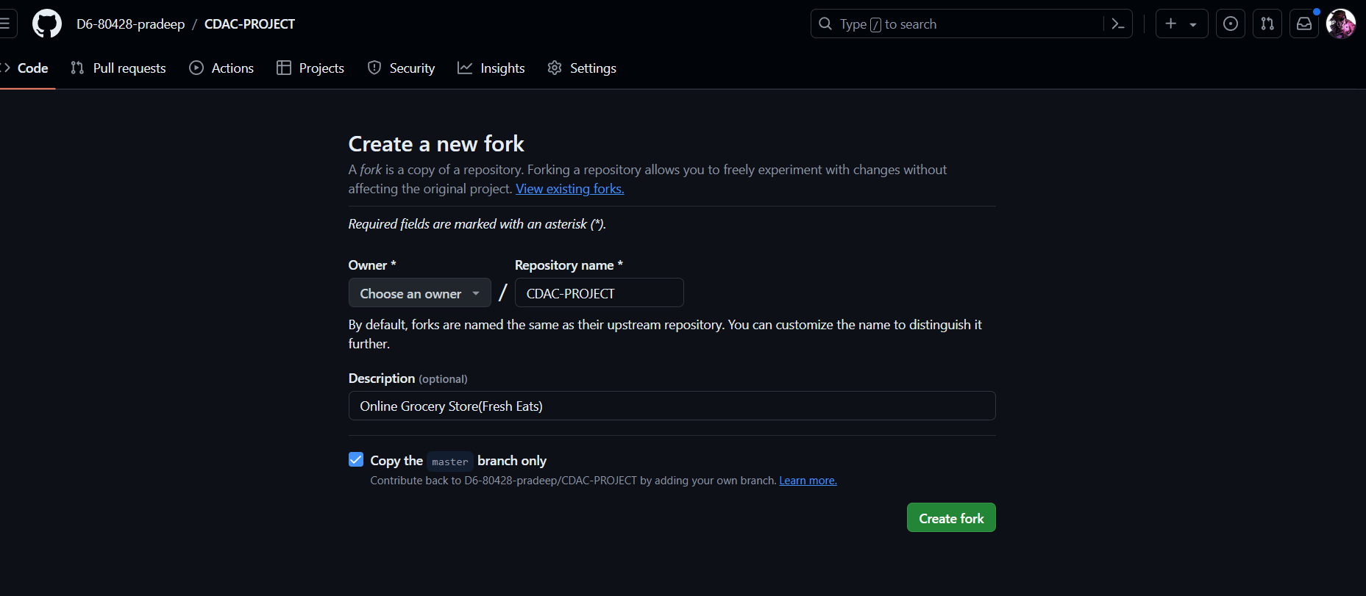



**15. Pull Requests in Action:**

* **Sharing Your Work:** A pull request is a way to propose changes from your forked repository back into the original repository. It allows the owner (or collaborators) to review your changes before merging them.
* **Collaboration and Review:** Through pull requests, team members can review each other's code, discuss changes, and suggest improvements before integrating them into the main codebase.

**16.Raising Issues and Tracking Progress**

**Opening & Closing Issues:**

* **Identifying Problems:** An issue is a way to report a bug, request a new feature, or ask a question about a repository.
* **Tracking and Resolution:** You can open issues on a repository, assign them to team members, and track their progress towards resolution. Closing issues indicates they've been addressed.

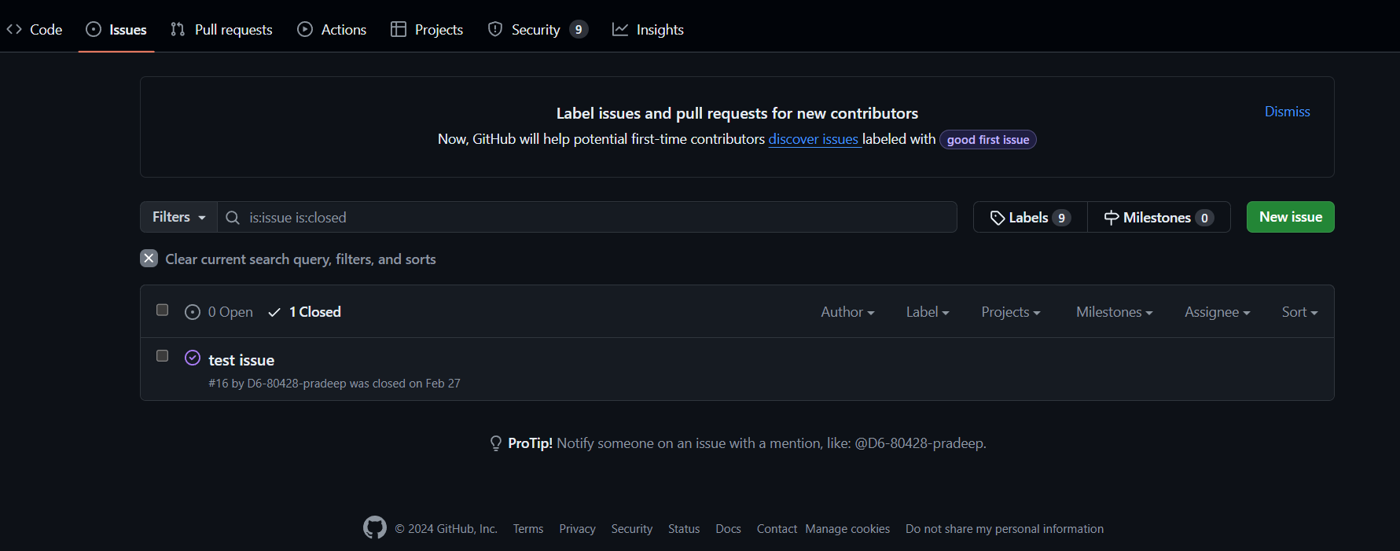



**17.Organizing Work with GitHub Projects**

* **Managing Tasks:** Projects offer a visual way to organize your work within a repository. You can create boards, add cards for tasks, and categorize them based on status (e.g., "to do," "in progress," "done").
* **Enhanced Collaboration:** Projects provide a collaborative environment for teams to track progress, assign tasks, and stay on the same page.

**18.The Importance of a README File**

* **Project Introduction:** A README file is a plain text file located in the root directory of your repository. It serves as the first point of reference for anyone looking at your project.
* **Providing Context:** A good README typically includes information like project description, installation instructions, usage examples, and
* contribution guidelines. This helps others understand your project's purpose and how to get involved.

